3 Marks
1. Non-ideal solution exhibit either positive or negative deviations from Raoult’s law. What are these deviations and why are the caused? Explain with one example for each type.
2.a) Why is an increase in temperature observed on mixing chloroform and acetone?
b) Why does sodium chloride solution freeze at a lower temperature than water?
3. A Solution of glycerol (C₃H₈0₃) in water was prepared by dissolving some glycerol in 500g of water. This solution has a boiling point of 100.42C while pure water boils at 100-C. What mass of glycerol was dissolved to make the solution?
4. Determine the amount of CaCl₂ (i=2.47) dissolved in 2.5 litre of water such that is osmotic pressure is 0.75 ATM at 27⁰C
5. The molar freezing point of depression constant for benzene is 4.90Kgmol⁻¹. Selenium exists as polymer Se. When 3.26gm if Seis dissolved in 226 gm of benzene, the observed freezing point is 0.1127 lower than for pure benzene. Decide the molecular formula of selenium

5 Marks
1. a) State Raoult’s Law for a solution containing volatile components. How does Raoult’s law become a special case of henry’s law
b) 1.00g of a non-electrolyte solute dissolved in 50g of benzene lowered the freezing point of a benzene is 0.40K. Find the molar mass of the solute.
2. Calculate the molarity of a sulphuric acid solution in which the mile fraction of water is 0.85.
Composition is given alongside.
i) Are the A-B intersections weaker, stronger of the same magnitude as A-A and B-B
ii) Name the type of deviation shown by this system from Raoult’s Law.
iii) Predict the sign of Δ_{Mix}H for this system
iv) Predict the sign of Δ_{Mix}V for this system.
v) Give an example of such system.
vi) What is the azeotrope will this system form, if possible?
3 Marks
1. Determine the value of equilibrium constant and ΔG⁰ for the following reaction:
Ni(S)+2Ag⁺(aq) →Ni²⁺(aq) +2Ag(S) (E⁰=1.05V)
2. Calculate the standard electrode potential of Ni²⁺//Ni electrode if emf of the Ni²⁺//Ni (0.01) // CU²⁺(0.1)/Cu(s) electrochemical cell is 0.059V. Given E⁰=0.34 V
3. The resistance of conductivity cell filled with 0.1 M KCI solution is 100 Ohm. If the resistance in the same cell when filled with 0.02 M KCI solution is 520 ohm, calculate the conductivity and molar conductivity 0.02 M KCI solution. Conductivity of 0.1 M KCI solution is 1.29 m⁻¹
4. Give an example of a fuel cell and write the cathode and anode reaction for it.

5 Marks
1. i) Define the molar conductivity of a solution and explain how molar conductivity changes with change in concentration of solution for a weak and strong electrolyte.
ii) The resistance of a conductivity cell containing 0.001KMCI solution at 298K is 15000.
What is the cell constant, if the conductivity of 0.01MKCI solution at 298K is?

2. i) Write the formulation for galvanic cell in which the reaction
Cu(s) + 2Ag⁺(aq) → Cu²⁺ (aq) + 2Ag(s)
Takes place, identify the cathode and the anode reaction in it.
ii) Write Nernst equation. Calculate the emf of the following cell:
Sn(s)/Sn²⁺(0.04M)//H⁺(0.02M)H₂(g),Pt(s) (Given E⁰Sn²⁺/Sn=0.14v)

3 Marks
1. Show that in a first order reaction, time required for completion of 99.9% is 10 times of half life (t_{1/2}) of the reaction.
2. The rate constants of a reaction at 500K and 700K are 0.02s⁻¹ and 0.07s⁻¹ respectively. Calculate the values of E_{a} and A.
3. A first order reaction takes 40 min for 30% decomposition. Calculate t_{1/2+}
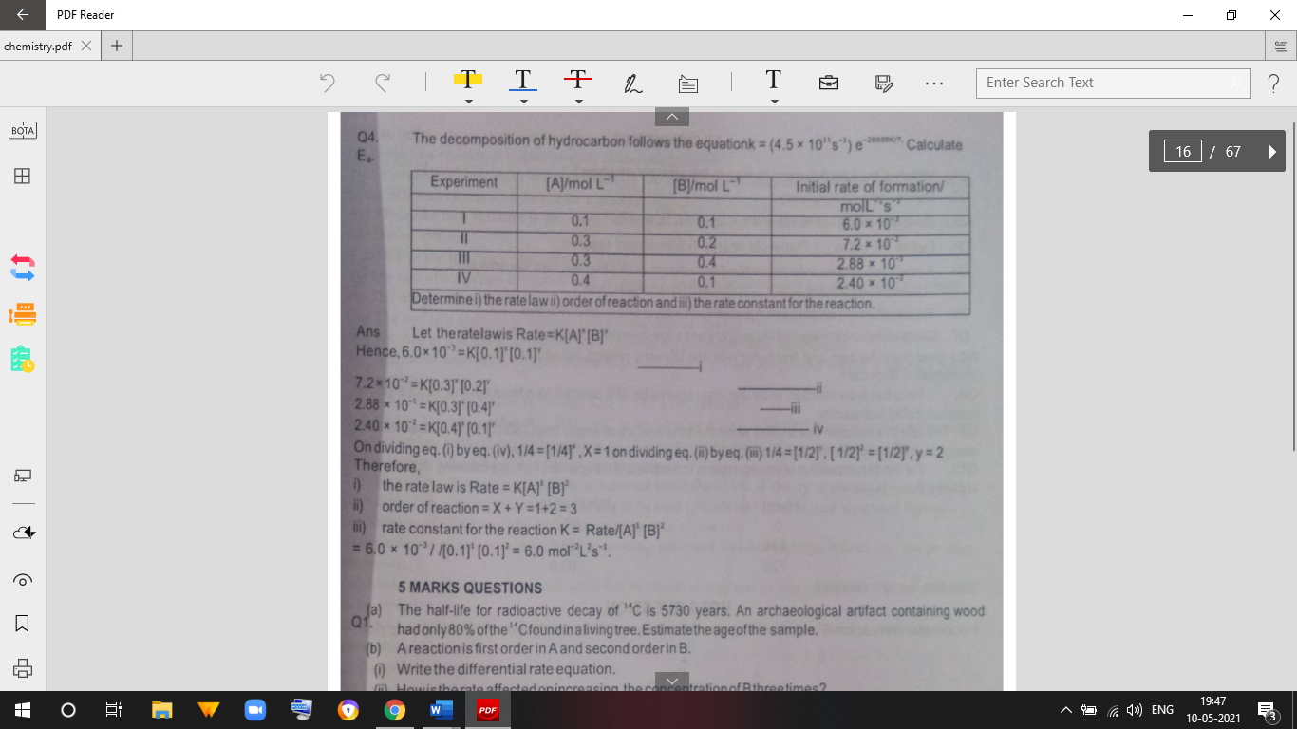
4. The decomposition of hydrocarbon follows the equation k= (4.5*10¹¹s⁻¹) e^{-28000k} Calculate

____________________________________________________________________________

5 Marks
1.(a) The half-life for radioactive decay of ¹⁴C is 5730 years. An archaeological artifact containing wood had only 80% of the ¹⁴C found in a living tree. Estimate the age of the sample.
(b) A reaction is first order in A and second order in B.
(i) Write the differential rate equation.
(ii) How is the rate affected on increasing the concentration of B three times?
(iii) How is the rate affected when the concentrations of both A and B are doubled?

3 Marks
1. What is colloidion?
2. Why do we add alum to purify water?
3. Of physisorption and chemisorption, which type of absorption on account of formation of chemical bond.
4.(i) How can colloidal sol. Of sulphur in water be prepared?
(ii) What is electrophoresis sue to?
(iii) Why is Fe (OH)₂ colloid+ vely charged when prepared by adding FeCI₂ to hot water?
5.(i) On the basis on Hardy Schultz rule, explain why the coagulating power of phosphate is higher than chloride?
(ii) How does delta form at the meeting place of sea and river water?
(iii) Why is chemisorption referred to as activated adsorption?

5 Marks
1. What is absorption? How adsorption is classified? How does adsorption of a gasona solid surface vary with (i) Temperature (ii) Pressure
2. (a) Define
(i) Kraft temperature (ii)Zeta potential (iii) Brownian movement.
(b) Arrange the following ions in increasing order of flocculating power to precipitate As₂S₃
(c) Give an example of oil in water and water in oil type emulsion.

3 Marks
1. Explain the following: -
(i) Zinc but not copper is used for recovery of Ag from the complex [ Ag (CN)₂]
(ii) Partial roasting of sulphide ore is done in the metallurgy of copper.
(iii) Extraction of Cu from pyrites is difficult than that from its oxide ore through reduction.
2. Explain the method for obtaining pig iron from magnetite.
3. Describe the principles of extraction of copper from its ore.
4. Name the principal ore of aluminium and describe how AI is extracted from its ore.
5. Described the principals of extraction od Zinc from zinc blende.
6. Complete the following chemical equation.
(i) SO₃ + H₂SO₄→
(ii) Fe³⁺ + SO₂ + H₂0→
(iii) SO2+MnO4 ̶ + H₂O→
7. (a) H₂S is less acidic than H-S bond is less.
(b) Boiling point of H₂O is more than H₂S why?
8. What is meant by the term lanthanoid contraction? What is due to and what consequences does it have on the chemistry of elements following lanthanoids in the periodic table?
9. Compare lanthanoids and actinoids with reference to their:
a) Electronic configuration of atoms
b) Oxidation states of elements
c) General chemical reactivity of elements.
10. How would you account for the following:
a) Mn(III) undergoes disproportion reaction easily.
b) Co(II) is easily oxidized in the presence of strong ligands.
11. Give reasons for the following:
(i) First ionisation energies of 5d elements are higher than those of 3d and 4d elements. Actinoid contracts greater from element to element than lanthanoid contraction.
12. Explain the following observation about the transition/inner transition elements:
i) There is general in increase in density of element from titanium (Z=22) to copper (Z=29).
ii) There occurs much more frequent metal-metal bonding in compounds of heavy transition element series.
iii) The greater number of oxidation states are exhibited by the members in the middle of a transition series
________________________________________________________________________________

